**Introduction to Arduino**

An Arduino is a Microcontroller board.

A Microcontroller is a Microprocessor ( The brains of a computer ) with some additional functionality on the Chip to enable it to store data and communicate with the outside world.

There are a few things that make up the whole Arduino Ecosystem.

**The Boards**

When we say Arduino we tend to think of the board that is now called the Uno. We will see some of the others later.

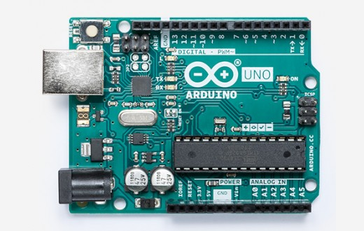

Arduino is made of other things as well.

The Arduino IDE ( Integrated Development Environment ) This is where we write our code, find and fix the bugs, send the code to the Arduino and can monitor the arduino using the serial port.

The Arduino language. This is a programming Language called C++ that has been simplified to make it more accessible. <https://www.arduino.cc/reference/en/>

The Arduino Libraries. Software written usually in C++ to enable many different electronics components to work with the Arduino.

The Arduino BootLoader. A small program that runs on the Microcontroller that makes programming the using board the USB port simple.

**Other Arduino boards.**

There have been and there are many variants of the Arduino.

<https://store.arduino.cc/>

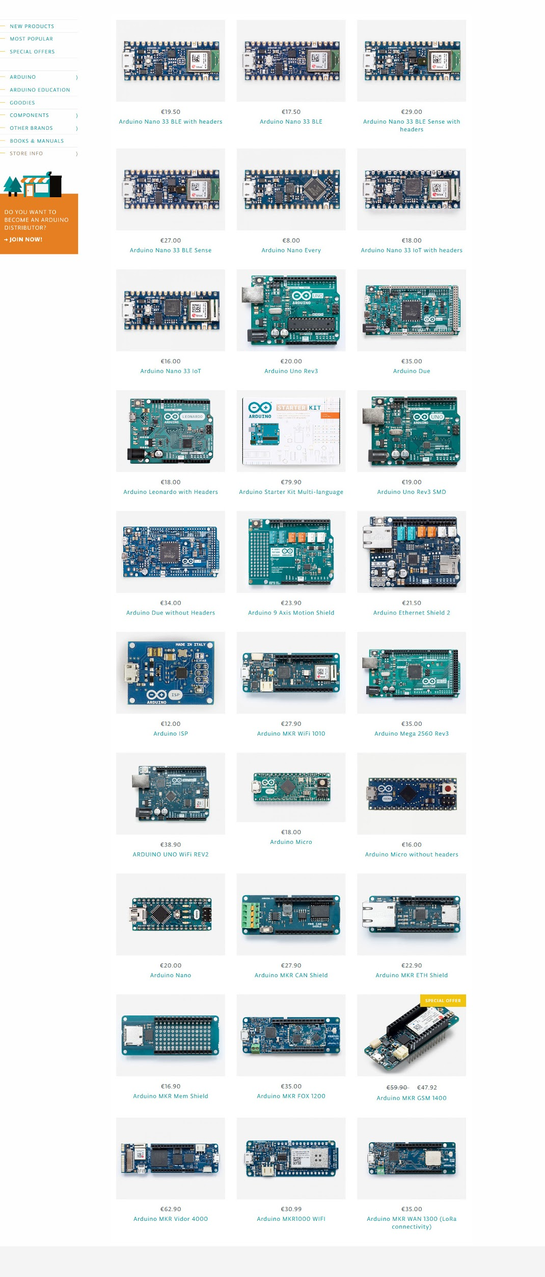

But it’s not necessary to know about all of these to get started.

A couple of alternatives to the Uno.

**Arduino Nano.**

Same chip as the Uno but in a smaller form factor.

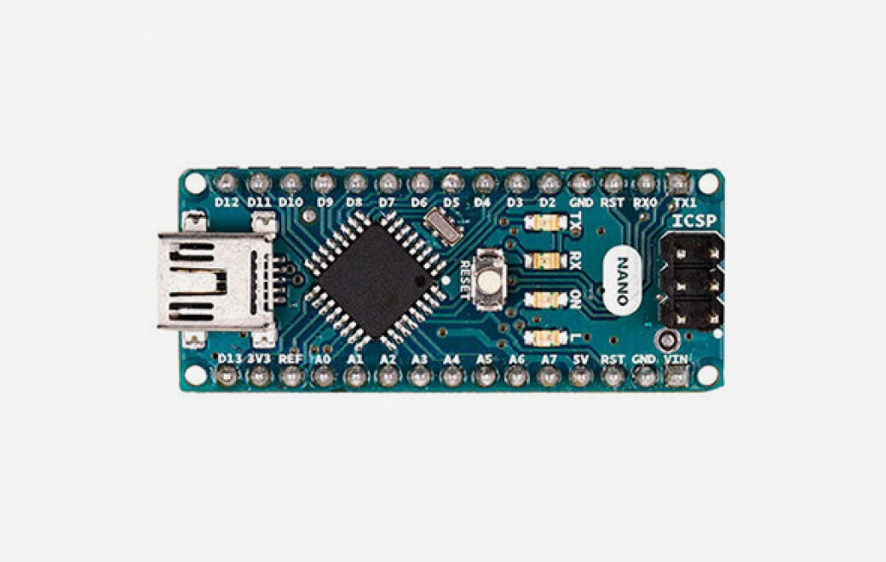

**Note:** Has just been updated with a new processor and now comes in different variants.

**Arduino Mega 2560**

Bigger than the Uno with a faster Processor chip on it.

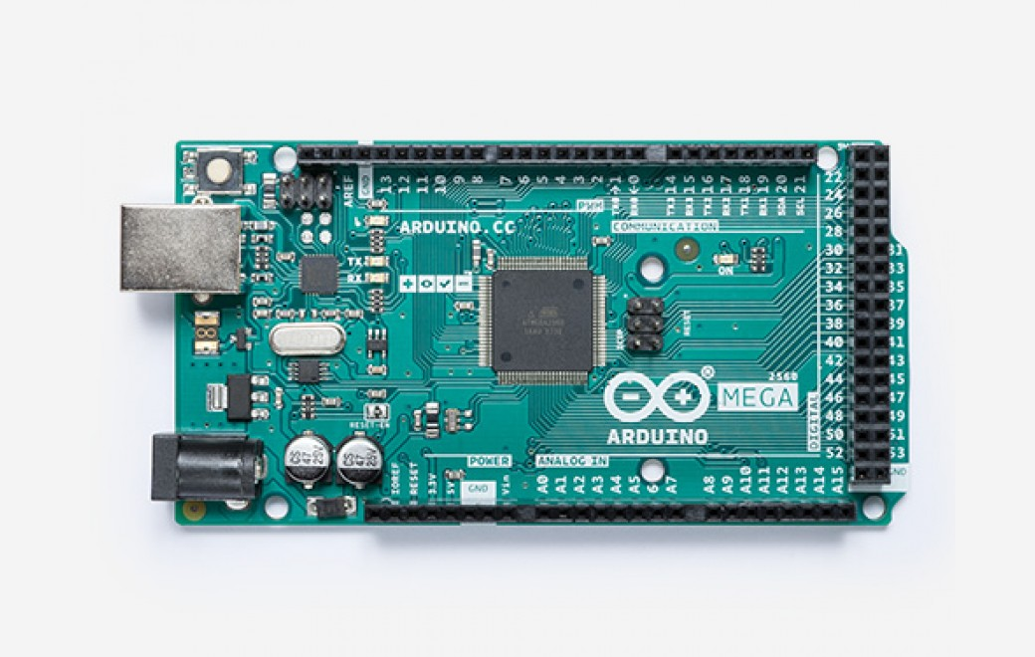

**Other notable boards for creative work.**

**Leonardo and Micro**

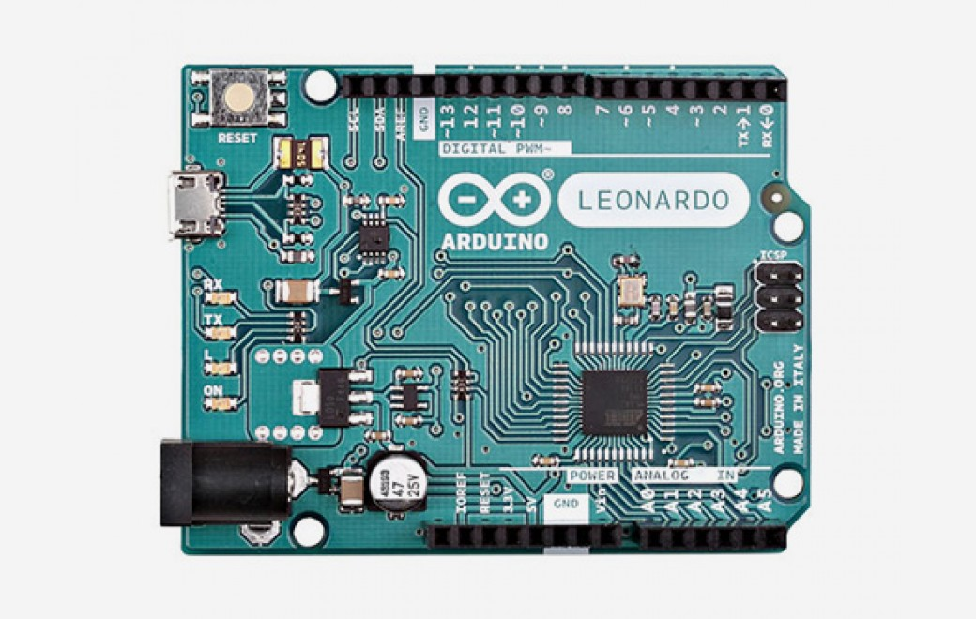

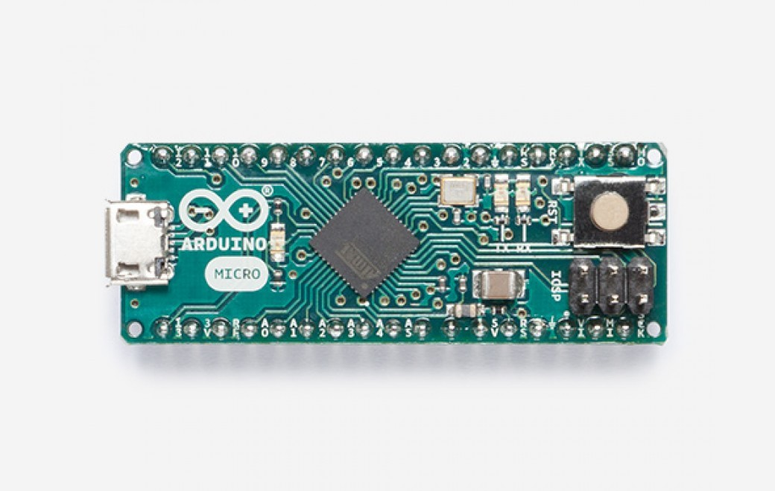

Both of these when connected to a computer can be recognised as a mouse or a keyboard.

This means that software running on the computer can be controlled by the Arduino.

**Other Boards.**

**Arduino Clones.**

The Arduino hardware and software is open source. This enables other companies to create

compatible boards and clones of Arduino boards.

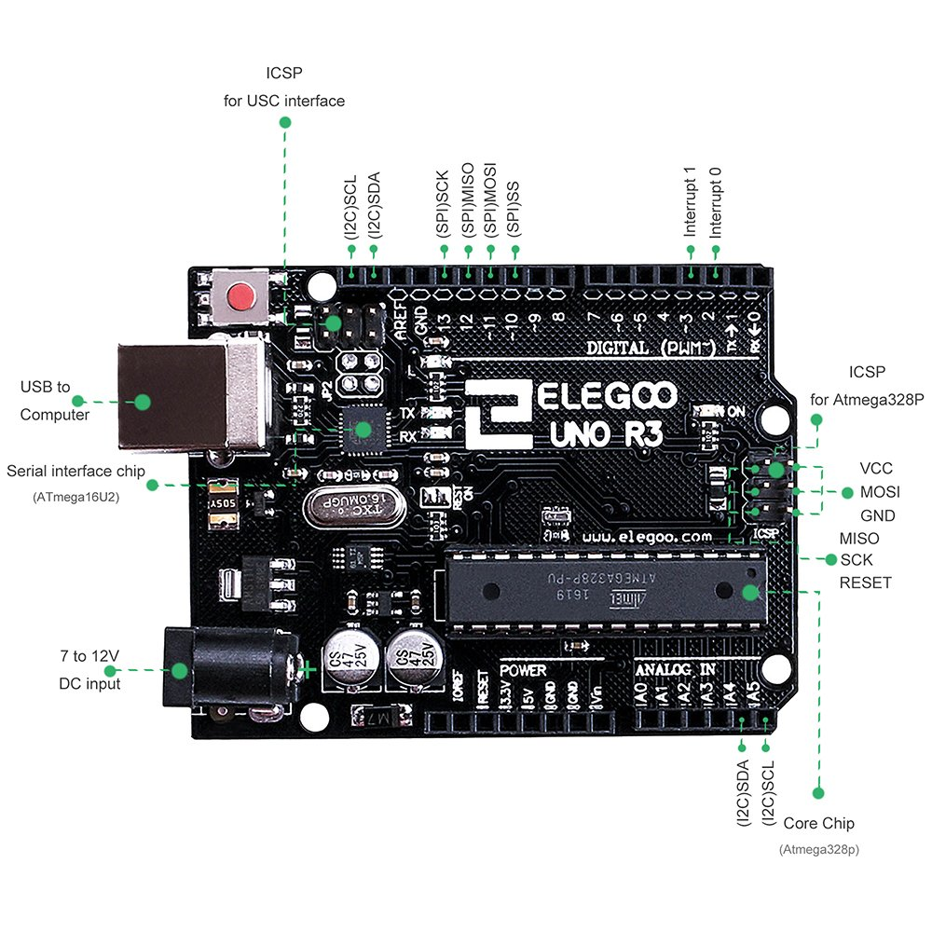

**ESP8266 boards**

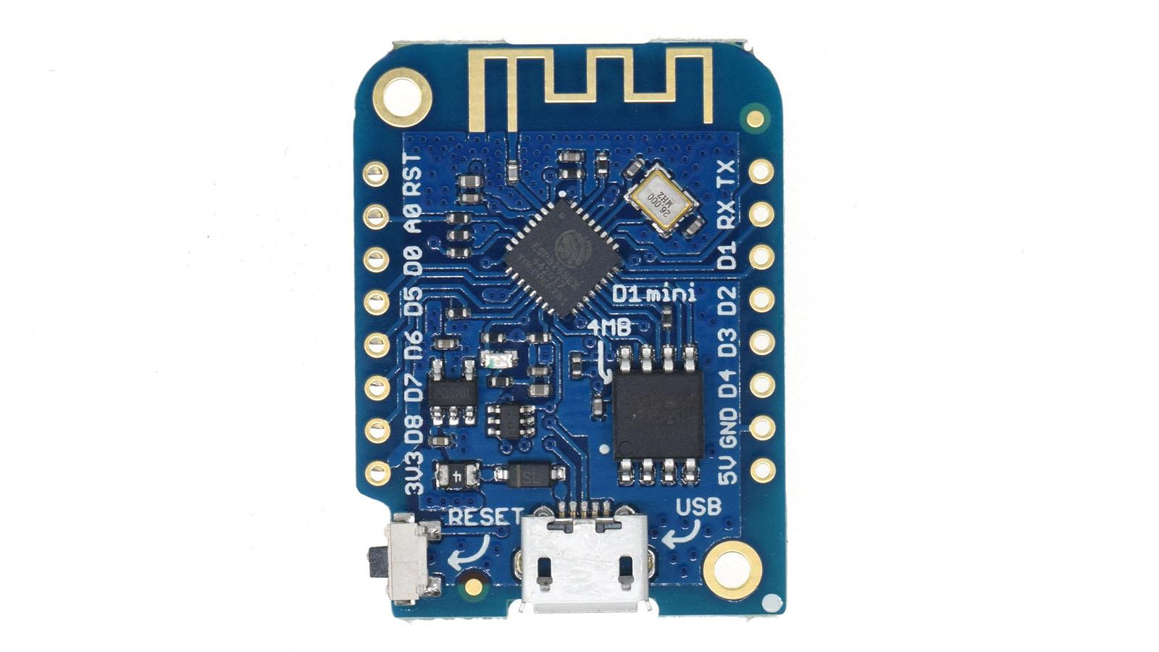

Very cheap approx £2 - £3 small boards that enable wi-fi to be used in projects

**Wearable**

**Lillypad**

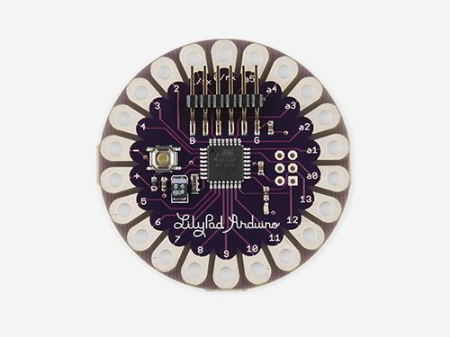

[**https://www.sparkfun.com/products/13342**](https://www.sparkfun.com/products/13342)

**Adafruit Flora**

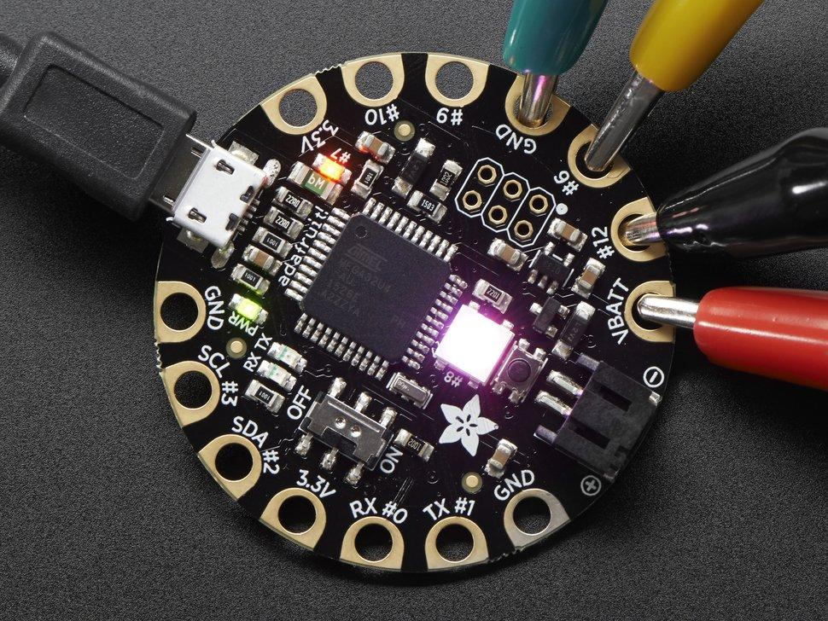

<https://www.adafruit.com/product/659>

**BBC Microbit.**



<https://en.wikipedia.org/wiki/Micro_Bit>

The Microbit - a BBC education Project. Great board uses ARM M0 Processor. A weird Form Factor makes connecting it to the real world a bit difficult.

**Adafruit - circuit Python boards**

<https://www.adafruit.com/category/956>

Feather and Metro Boards. Use Arm M0 and M4 Processors so more powerful than normal Arduino. Adafruit are pushing Circuit Python for programming. Not quite as well supported yet.

**Raspberry Pi.**

Small computer. Runs Linux, more complicated for connecting to the outside world.

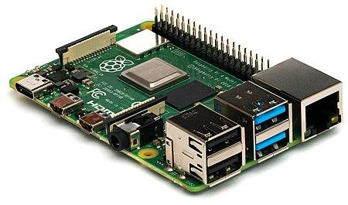

Massively Successful small board computer. Not quite as robust as arduino for interfacing to, can easily be damaged. More powerful and needs more power.

**Other other.**

Beaglebone - <https://beagleboard.org/bone>

Jetson Nano - <https://developer.nvidia.com/embedded/jetson-nano-developer-kit>

Games Boards - 32 Blit <https://32blit.com/>

**Other Other other**

- Lots of ‘Professional’ Development boards’

<https://os.mbed.com/platforms/>